**DEEP LEARNING**

Deep learning is a specific approach used for building and training neural networks, which are considered highly promising decision-making nodes. An algorithm is supposed to be deep if the input data is passed through a series of nonlinear transformations before it becomes the final output.

In the series of learning deep learning the first question which arises is what is the fundamental difference between deep learning and neural networks and how it is related to Artificial Intelligence (AI) and Machine learning (ML). Let us first try to understand the relationship between AI, ML and Deep Learning.

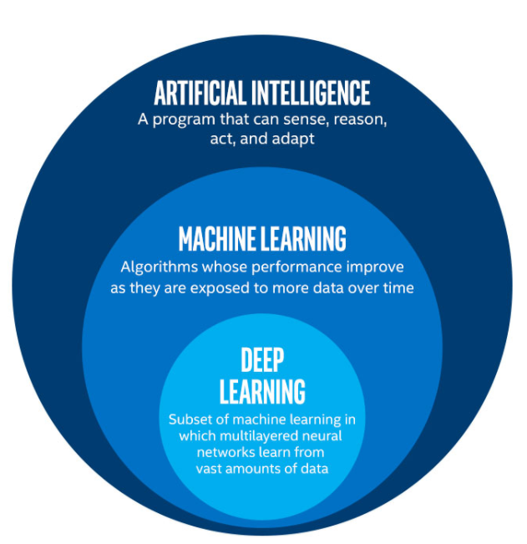

From the above figure, it is evident how all of these fields are related to each other.

Currently, AI is advancing at a great pace, and deep learning is one of the contributors to that. Deep learning is a sub-field of machine learning dealing with algorithms inspired by the structure and function of the brain called artificial neural networks.

**Comparison of deep learning and machine learning**

|  |  |
| --- | --- |
| **DEEP LEARNING** | **MACHINE LEARNING** |
| It tends to perform well with the amount of data. | ML models stop improving after a saturation point. |
| Deep learning removes the manual identification of features in data and, instead, relies on whatever training process it has to discover the usage patterns in the input examples. | Feature extraction is done by a human. |
| As a result, the training process becomes easier and faster, and it helps in advancing the field of artificial intelligence. | Comparatively, it is time-consuming and less efficient. |

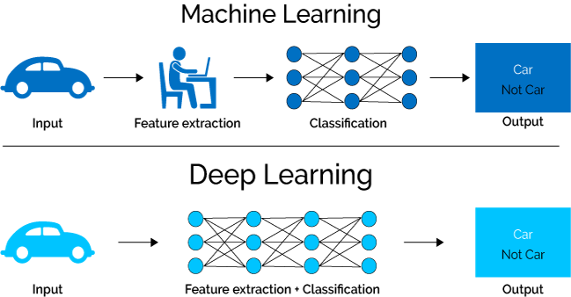

**DEEP LEARNING AND NEURAL NETWORKS**

Neural networks or connectionist systems are the systems which are inspired by our biological neural networks.

Advantages of a neural network includeself organization, i.e. it can create its representation of the data given as input, operation in real time scenarios taking advantage of its parallel architecture and hence fast responses and adaptive learning, i.e. it learns on it own from the given data.

The basic structure of a neural network or artificial neural network includes i/p layer, hidden layer, and the output layer. Deep learning is a Neural Network consisting of a hierarchy of layers. These series of layers, between input and output, identify the input features and create a set of new features based on the data, just as our brain. In deep learning the more layers a network has, the higher the level of features it will learn. The output layer combines all these features and makes a prediction.

Major terminologies used in the context of a neural network includes :

1. Learning rate, i.e. alpha, which helps in controlling the training rate of the system by controlling the magnitude with which weight updation takes place.
2. Activation function, which is responsible for converging the system towards the desired output. Majorly used activation function includes bipolar activation function, binary activation function, unipolar sigmoidal activation function, bipolar sigmoidal activation function, ramp activation function and so on.
3. Net Input for a neuron or perceptron is mathematically defined as the summation of each labeled input given to that neuron multiplied with the corresponding interconnection weight.
4. Interconnection weight, can be excitatory (+ve) as well as inhibitory(-ve) in nature. Excitatory weights are those which helps in increasing the actual output to get better performance. Whereas, Inhibitory weights are those which decreases the actual output.
5. Actual Output is the output we observe as a result of an activation function applied to the net input.

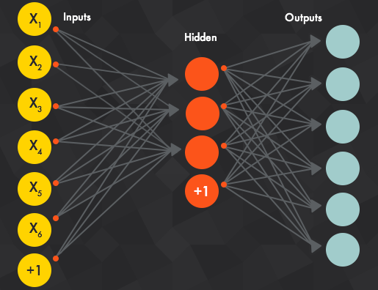

Deep Learning is broadly classified into supervised and unsupervised networks.

SUPERVISED NETWORK: Under this, we compare the actual output with the desired output and based on that an error signal (Least mean square error) is generated which helps in correcting the system for better convergence. Here the data preferred for training includes labeled data.

UNSUPERVISED NETWORK: Under this, there is no role of desired output as no error signal is generated. The system learns on its own, correct it every time in the hope of achieving better conversion. Here the data preferred for training includes unlabeled data.

**DEEP LEARNING**

SUPERVISED UNSUPERVISED

Artificial Neural Network Self Organizing Maps

Convolution Neural Network Boltzmann Machines

Recurrent Neural Network Auto-Encoders

From the above classification, it is clear what different learning fields deep learning covers. However, in the series of learning deep network in following sections, we will be majorly interested in supervised deep learning which includes Artificial Neural network (ANN), Convolution Neural Network (CNN) and Recurrent Neural Network (RNN).

**Artificial Neural Network**

Artificial Neural Network is a structured model which imitate the working of the human brain. Comparable terminologies in a biological neuron and an artificial neuron includes the following:

|  |  |
| --- | --- |
| **BIOLOGICAL NEURON** | **ARTIFICIAL NEURON** |
| CELL | NEURON |
| CELL BODY (SOMA) | NET INPUT |
| AXON | OUTPUT |
| DENDRITES | WEIGHTED INTERCONNECTIONS |

Comparison of Artificial neuron and Biological neuron

1. **SPEED**: An artificial neuron has fast responses as compared to a biological neuron.
2. **PROCESSING**: Both the neurons exhibit parallel architecture and hence support parallel processing. But, comparatively an artificial neuron processes faster as compared to a biological neuron.
3. **STRUCTURE**: A biological neuron comprises of 10^11 neurons and 10^15 interconnections. As compared to this giant structure ANN has a simplified structure and it basically depends upon the application for which it is being designed and the designer.
4. **MEMORY**: In a biological neuron, information is stored in interconnections or synapse strength. Whereas, in case of an artificial neuron it is stored in a separate contiguous memory.
5. **FAULT TOLERANCE**: A biological neuron is fault tolerant due to its distributed structure whereas an artificial neuron is not. On another hand, an artificial neuron does not support redundant information whereas a biological neuron does.
6. **CONTROL MECHANISM**: As an artificial neural network is modeled using a computer, therefore its control unit lies in central processing unit (CPU) of the computer. There is no such control unit in case of a biological neuron.

Main components of an Artifical Neural Network includes the following:

1. **INTERCONNECTIONS**: Under this, we have a number of ANN architectures which includes Single Layer Feed Forward Neural Network, Multi-Layer Feed Forward Neural Network, Feedback Neural Network, and Recurrent Neural Network. These neural networks will be discussed in the following section of ANN.
2. **LEARNING ALGORITHMS**: It is broadly classified into parameter learning where our primary concern is weight updating and structure learning where our concern is regarding updation of no. of neuron in each layer and no of hidden layers.

Further, it includes three learning categories named Supervised, Unsupervised and Reinforcement Learning.

1. **ACTIVATION FUNCTION**: It is broadly classified into discrete activation function and continuous activation function. Few examples of discrete activation function include binary, bipolar, linear, etc. On the other hand, continuous activation function includes the sigmoidal activation function.

Two important training phases to be included in ANN are FEED FORWARD PHASE and BACKPROPAGATION PHASE. In brief feed forward phase can be thought as a training phase including calculation of actual output from the given input and backpropagation as a training phase which is responsible for generating an error signal and back propagating it to the hidden and input layer neurons for updating interconnection weights.

**CONVOLUTION NEURAL NETWORK**

CNNs have broad applications in image and video recognition, recommender systems and natural language processing.

A convolution neural network has three types of layers:

1. **Convolution layer:**  It is the first layer in a Convolution neural network which basically comprises of three components, i.e. Input Layer, Kernel (filter) and the output layer. It takes input in the form of a matrix. Over one input matrix, we apply a no of kernels or filters with different window size in order to extract features in the form of a feature map. As a result, we obtain a no of Output matrices or feature maps.
2. **RELU:** ReLU stands for rectifier linear unit which is a max activation function. It is used to incorporate non-linearity in the input matrix.
3. **Pooling layer:** The main purpose of a pooling layer is to reduce the number of parameters in the input matrix fed in this layer. As a result, it helps in avoiding overfitting and reduces computation.
4. **Fully Connected Layer:** Here the output of pooling layer is fed as input after flattening. These fully connected layers are used for the purpose of classification. Generally, the function used for classifiers is softmax activation function.

**RECURRENT NEURAL NETWORK**

In neural network recurrent means feeding output to the same processing unit or other processing units or both at the same time. Also, this procedure is applicable to both inputs as well as hidden layer neurons. Here in the context of deep learning recurrent neural network proves to be beneficial for recognizing a sequence in data. This functionality is carried out with the help of short term memory it exhibits via taking two inputs, first one is the present input and the second one is the past input (output feedback to the system).

Recurrent neural networks are highly used in Language modeling and prediction, Speech Recognition, Machine Translation, Image Recognition and Characterization and so on.

One of the capability it exhibits to overcome the problem of short term memory is long short term memory (LSTM). LSTM carries out two operations at the same time, i.e. using past information to predict the future information and omitting the unnecessary information at that step of time.

Working of LSTM and Recurrent neural networks will be discussed in detail in the following section of RNN.

APPLICATION OF DEEP LEARNING

Some of the major applications of deep learning include:

1. Colorization of Black and White Images.
2. Adding Sounds To Silent Movies.
3. Automatic Machine Translation.
4. Object Classification in Photographs.
5. Automatic Handwriting Generation.
6. Character Text Generation.
7. Image Caption Generation.
8. Automatic Game Playing.
9. Autonomous Vehicle

But in this chapter, we will be discussing the application of deep learning in autonomous vehicles. Autonomous Vehicle basically means self-driving cars. The major components of an autonomous vehicle includes are:

1. Computer Vision
2. Sensor Fusion
3. Localization
4. Path Planning
5. Control

All these components will be discussed in detail following sections.